Érettségi feladatok gyűjteménye angol nyelven
Esszék
Egyetemes középkor
Középszint
2005–2019

Az eredeti feladatsorok és javítási útmutatók lelőhelye:
https://www.oktatas.hu/kozneveles/erettsegi/feladatsorok

Szerkesztette: Búcsú Ákos és Fekete Bálint

Összeállította: Búcsú Ákos

Verziószám: 2020_v1

A megjelenést az Újkor.hu – A velünk élő történelem tette lehetővé 2020-ban.

www.ujkor.hu

1. This task is about the culture of mediaeval knighthood. (short)
Use the sources and your own knowledge to present the elements of the culture of knighthood which have become parts of today’s European culture and those which are in contrast with it.

’When you sneeze or need to cough, make sure you turn the other way, and courtesy dictates that not a drop should fall on the table. Wash your hands well after a meal too; do not spit into the dish and do not splash the water about.’ (Etiquette for prospective knights; 13th century)

„Ha tüsszentesz, vagy elfog a köhögés, legyen rá gondod, hogy másfelé fordulj, és úgy udvarias, ha egyetlen csöpp se hull az asztalra. Evés után is szépen moss kezet: ne köpj a tálba, s ne fröcsköld a vizet.” (Lovagjelöltek illemtana; XIII. század)

’The two good knights agreed to pay the ladies a visit and offer them all the help that was in their power. Without delay they presented themselves in front of the Duchess of Normandy and the other ladies, who all rejoiced at their arrival.’ (The chronicle of Froissart; ca. 1400)

„A két jó lovag megállapodott, hogy elmegy a hölgyekhez, segít rajtuk erejéhez mérten. Legott Normandia hercegnéje s a többi hölgy elé járultak, ezek igen örvendeztek jöttükön” (Froissart krónikája; 1400 körül)

_____________________________________________________________________________________________________________________
_____________________________________________________________________________________________________________________
_____________________________________________________________________________________________________________________
_____________________________________________________________________________________________________________________
_____________________________________________________________________________________________________________________
_____________________________________________________________________________________________________________________
_____________________________________________________________________________________________________________________
_____________________________________________________________________________________________________________________
_____________________________________________________________________________________________________________________
_____________________________________________________________________________________________________________________
_____________________________________________________________________________________________________________________
_____________________________________________________________________________________________________________________
_____________________________________________________________________________________________________________________
_____________________________________________________________________________________________________________________
_____________________________________________________________________________________________________________________
_____________________________________________________________________________________________________________________

2. This task is about the Islamic faith. (short)
Describe the most important characteristics of the Islamic faith, using the sources and your own knowledge. In your answer, include the other religions that influenced the development of Islam.

‘Memories going back to the 5th century maintained the names of pagan gods of the Arabs, (including also Allah and his three daughters). […] Mohammed belonged to the poorer branch of the Hashim clan of the Quarysh tribe. On his long-distance trading journeys as a caravan guide, [he got acquainted with religions other than his own]. […] Merging the elements of these with pagan Arabic traditions and including the ethical requirements of both, he formed his own religion. […] An example of the blending of religious traditions is the belief that the pagan sanctuary of the Kaaba was built by the forefather Ibrahim (The Abraham of the Old Testament), and the black meteorite rock was given as a present by Archangel Gabriel to an ancestor in the Quarysh tribe.’ (Historian György Székely)

„Az V. századig terjedő emlékek az arabok pogány istenségeinek nevét tartották fenn (köztük van Allah és az ő három leánya is). […] Mohamed a mekkai Kurais törzs Hasim nemzetségének szegényebb ágából származott. Mint karavánvezető, távolsági kereskedő útjain [az övétől eltérő vallásokat is megismert] […]; ezek elemeiből és az arab pogányság hagyományaiból, mindezek etikai követelményeiből ötvözte új vallását. […] A vallási hagyományok összeolvadását mutatja, hogy a Kába pogány szentélyét Ibrahim ősatya (az ótestamentumi Ábrahám) építette, a fekete meteorkövet pedig Gábriel arkangyal ajándékozta egy Kurais törzsbeli ősnek.” (Székely György, történész)

‘Maria’s son the Messiah is only a messenger. Messengers have already passed away [from the living] before him. His mother is one of the righteous ones.’ (Excerpt from the Koran)

„A Messiás, Mária fia csupán egy küldött. Már előtte is eltávoztak a küldöttek [az élők sorából]. Az ő anyja az igazak közül való.” (Részlet a Koránból)

_____________________________________________________________________________________________________________________
_____________________________________________________________________________________________________________________
_____________________________________________________________________________________________________________________
_____________________________________________________________________________________________________________________
_____________________________________________________________________________________________________________________
_____________________________________________________________________________________________________________________
_____________________________________________________________________________________________________________________
_____________________________________________________________________________________________________________________
_____________________________________________________________________________________________________________________
_____________________________________________________________________________________________________________________
_____________________________________________________________________________________________________________________
_____________________________________________________________________________________________________________________
_____________________________________________________________________________________________________________________
_____________________________________________________________________________________________________________________
_____________________________________________________________________________________________________________________
_____________________________________________________________________________________________________________________
3. This task is about medieval culture. (short)
Describe the role of the Christian church in medieval science and culture, using the source and your own knowledge.

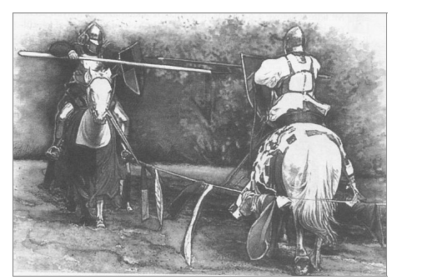
A tournament

‘Let the wise men unveil everything, let them seek out the heights of the sky, the regions of earth […] what other will they come to but trouble, pain and a grip around the soul. It was speaking out of personal experience when someone said: “I set my heart on acquiring complete wisdom and all knowledge […], and all I learnt was that this only leads to […] headache: in much knowledge you will find only much doubt.”’ (On the misery of the human condition by Pope Innocent III)

„Tárjanak fel mindent a bölcsek, kutassák ki az ég magasságát, a föld térségeit […] mi más lesz ebből számukra, mint vesződség, fájdalom és a lélek szorongattatása. Saját tapasztalatából tudta ezt az, aki így szólt: »Szívemet arra szántam, hogy megismerjek minden bölcsességet és minden tudományt […], s csak azt tudtam meg, hogy mindebből bajlódás […] származik, a sok tudományban csak sok kétséget találni.«” (III. Ince pápa: Az emberi sors nyomorúságos voltáról)

_____________________________________________________________________________________________________________________
_____________________________________________________________________________________________________________________
_____________________________________________________________________________________________________________________
_____________________________________________________________________________________________________________________
_____________________________________________________________________________________________________________________
_____________________________________________________________________________________________________________________
_____________________________________________________________________________________________________________________
_____________________________________________________________________________________________________________________
_____________________________________________________________________________________________________________________
_____________________________________________________________________________________________________________________
_____________________________________________________________________________________________________________________
_____________________________________________________________________________________________________________________
_____________________________________________________________________________________________________________________
_____________________________________________________________________________________________________________________
_____________________________________________________________________________________________________________________
_____________________________________________________________________________________________________________________

4. This task is about the economic history of medieval Europe. (short)
Describe the most significant changes of production methods and tools used in agriculture around the turn of the millennium, using the source and your own knowledge. In your answer, briefly include the demographic implications of the changes.

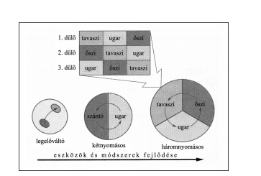
Agricultural methods in medieval Europe

Glossary:
dűlő: field
tavaszi: spring
őszi: autumn
ugar: fallow
legelőváltó: rotational grazing
kétnyomásos: two-field rotation
szántó: plough land
háromnyomásos: three-field rotation
eszközök és módszerek fejlődése: development of tools and methods

_____________________________________________________________________________________________________________________
_____________________________________________________________________________________________________________________
_____________________________________________________________________________________________________________________
_____________________________________________________________________________________________________________________
_____________________________________________________________________________________________________________________
_____________________________________________________________________________________________________________________
_____________________________________________________________________________________________________________________
_____________________________________________________________________________________________________________________
_____________________________________________________________________________________________________________________
_____________________________________________________________________________________________________________________
_____________________________________________________________________________________________________________________
_____________________________________________________________________________________________________________________
_____________________________________________________________________________________________________________________
_____________________________________________________________________________________________________________________
_____________________________________________________________________________________________________________________
_____________________________________________________________________________________________________________________

5. This task is about the history of the medieval Church. (short)
Describe the role of the medieval Church in culture, using the source and your own knowledge. In your answer, include education and the use of writing.

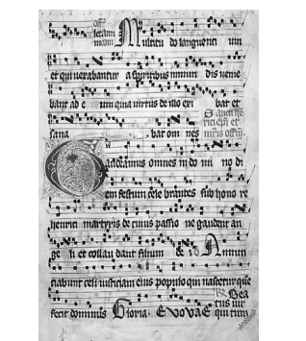
A page from a 14th-15th century manuscript (Graduale Aboense)

_____________________________________________________________________________________________________________________
_____________________________________________________________________________________________________________________
_____________________________________________________________________________________________________________________
_____________________________________________________________________________________________________________________
_____________________________________________________________________________________________________________________
_____________________________________________________________________________________________________________________
_____________________________________________________________________________________________________________________
_____________________________________________________________________________________________________________________
_____________________________________________________________________________________________________________________
_____________________________________________________________________________________________________________________
_____________________________________________________________________________________________________________________
_____________________________________________________________________________________________________________________
_____________________________________________________________________________________________________________________
_____________________________________________________________________________________________________________________
_____________________________________________________________________________________________________________________
_____________________________________________________________________________________________________________________

6. This task is about medieval towns. (short)
Describe the privileges of medieval towns, using the source and your own knowledge.

’Should a man or a woman spend a year and a day in the city of Bremen undisturbed […], whoever wishes to deprive them of their freedom after this shall be ordered to keep silent. And the person shall have the right to keep his freedom, as all (possible) rights contrary to this lapse at the end of the period mentioned.’ (Letters-patent granted by Frederick I, Holy Roman emperor, 1164)

„Ha egy férfi vagy nő Bréma városában […] egy évet és egy napot háborítatlanul eltöltött, annak, aki ezután szabadságát el akarná venni, hallgatást parancsoljanak. Neki pedig jogában áll szabadságát megtartani, minthogy az ezzel szemben (esetleg) fennálló jogok az említett idő alatt elévülnek;” (I. Frigyes német-római császár kiváltságlevele, 1164)

_____________________________________________________________________________________________________________________
_____________________________________________________________________________________________________________________
_____________________________________________________________________________________________________________________
_____________________________________________________________________________________________________________________
_____________________________________________________________________________________________________________________
_____________________________________________________________________________________________________________________
_____________________________________________________________________________________________________________________
_____________________________________________________________________________________________________________________
_____________________________________________________________________________________________________________________
_____________________________________________________________________________________________________________________
_____________________________________________________________________________________________________________________
_____________________________________________________________________________________________________________________
_____________________________________________________________________________________________________________________
_____________________________________________________________________________________________________________________
_____________________________________________________________________________________________________________________
_____________________________________________________________________________________________________________________

7. This task is about the Islamic religion. (short)
Describe the common origins of the Islamic and Christian religions, and the similarities and differences between them, using the source and your own knowledge.

‘The Messiah, Jesus, son of Mary, is only an apostle of Allah […]. Believe therefore in Allah and His apostles, and say not, “Three:” Do not do it, it will be better for you. God is only one God! Far be it from His glory that He should have a son! His, whatever is in the Heavens, and whatever is in the Earth! And God is a sufficient Guardian.’ (Qu’ran)

„Jézus, a Messiás, Mária fia csupán küldötte Allahnak, […]. Higgyetek hát Allahban és az Ő küldötteiben és ne mondjátok azt, hogy: »Három!« Hagyjátok abba! Jobb az nektek! Allah csupán egyetlen isten. Magasztaltassék! Nincs szüksége gyermekre, amikor Övé mindaz, ami az egekben és a földön van. Allah kiváló istápoló!” (Korán)

_____________________________________________________________________________________________________________________
_____________________________________________________________________________________________________________________
_____________________________________________________________________________________________________________________
_____________________________________________________________________________________________________________________
_____________________________________________________________________________________________________________________
_____________________________________________________________________________________________________________________
_____________________________________________________________________________________________________________________
_____________________________________________________________________________________________________________________
_____________________________________________________________________________________________________________________
_____________________________________________________________________________________________________________________
_____________________________________________________________________________________________________________________
_____________________________________________________________________________________________________________________
_____________________________________________________________________________________________________________________
_____________________________________________________________________________________________________________________
_____________________________________________________________________________________________________________________

8. This task is about Islam. (short)
Using the source and your own knowledge, describe the Jewish and Christian roots of the Islamic religion. Briefly include the holy scriptures.

’We believe in Allah, and in what has been revealed to us and what was revealed to Abraham, Isma'il, Isaac, Jacob, and the Tribes, and in what was given to Moses, Jesus, and the prophets, from their Lord: We make no distinction between one and another among them, and to Allah do we bow our will.’ (Quran)

„Hiszünk Allahban és abban, ami leküldetett hozzánk, és abban, ami leküldetett Ábrahámhoz, Izmaelhez, Izsákhoz, Jákobhoz és a törzsekhez, és abban, amit Mózes és Jézus kapott, és abban, amit a próféták kaptak az Uruktól. Nem teszünk különbséget közöttük, és mi Allahnak engedelmeskedünk.” (Korán)

_____________________________________________________________________________________________________________________
_____________________________________________________________________________________________________________________
_____________________________________________________________________________________________________________________
_____________________________________________________________________________________________________________________
_____________________________________________________________________________________________________________________
_____________________________________________________________________________________________________________________
_____________________________________________________________________________________________________________________
_____________________________________________________________________________________________________________________
_____________________________________________________________________________________________________________________
_____________________________________________________________________________________________________________________
_____________________________________________________________________________________________________________________
_____________________________________________________________________________________________________________________
_____________________________________________________________________________________________________________________
_____________________________________________________________________________________________________________________
_____________________________________________________________________________________________________________________

9. This task is about medieval guilds and town life. (short)
Using the source and your own knowledge, describe the main features of the functioning of medieval guilds.

’Any time an apprentice of the profession of wool weaving has completed his apprenticeship by the date agreed upon, after that let him go on working in the aforementioned profession freely wherever he wishes to. […] [Should the master for any reason] give up the practice of the profession of wool weaving completely, then he may pass on and find a new place for the above mentioned apprentice with a suitable person so that the apprentice may learn the profession from him. This new master, however, should be knowledgeable enough to be able to teach this apprentice appropriately.’ (Regulation of the cloth-makers of Champagne, 13th century)

„Valahányszor egy tanulófiú a gyapjúszövő mesterségben teljes tanulóidejét letölti a megállapodásban szereplő határnapig, utána az említett mesterségben ott legyen szabad neki tovább dolgoznia, ahol éppen akar. […] [Ha valamilyen okból a mester] a gyapjúszövés mesterségének gyakorlását teljességgel abbahagyná, akkor az említett tanulófiút átadhatja és elhelyezheti e célra alkalmas személynél, hogy annál tanulja ki az említett mesterséget, ám olyan tudású legyen ez a személy, hogy a nevezett tanulófiút e mesterségben megfelelő módon képes is legyen oktatni. (A champagne-i posztósok szabályzata, 13. század)

_____________________________________________________________________________________________________________________
_____________________________________________________________________________________________________________________
_____________________________________________________________________________________________________________________
_____________________________________________________________________________________________________________________
_____________________________________________________________________________________________________________________
_____________________________________________________________________________________________________________________
_____________________________________________________________________________________________________________________
_____________________________________________________________________________________________________________________
_____________________________________________________________________________________________________________________
_____________________________________________________________________________________________________________________
_____________________________________________________________________________________________________________________
_____________________________________________________________________________________________________________________
_____________________________________________________________________________________________________________________
_____________________________________________________________________________________________________________________
_____________________________________________________________________________________________________________________

10. This task is about medieval farming. (short)
Using the sources and your knowledge describe the role of new tools and techniques in the development of medieval agrarian production.

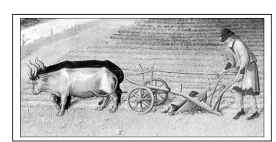
Medieval illustration of a plough

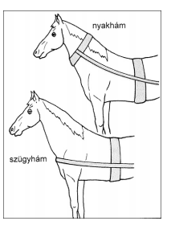
Two ways of harnessing a horse,
nyakhám: hose-collar
szügyhám, breast harness

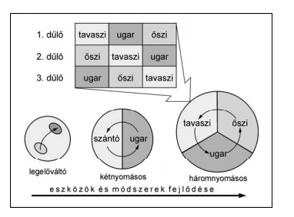
Land use in the Middle Ages

Glossary:
dűlő: balk
tavaszi: spring
őszi: autumn
ugar: fallow
legelőváltó: rotational grazing
kétnyomásos: two-course rotation
szántó: péough land
háromnyomásos: three-course rotation
eszközök és módszerek fejlődése: development of tools and methods

_____________________________________________________________________________________________________________________
_____________________________________________________________________________________________________________________
_____________________________________________________________________________________________________________________
_____________________________________________________________________________________________________________________
_____________________________________________________________________________________________________________________
_____________________________________________________________________________________________________________________
_____________________________________________________________________________________________________________________
_____________________________________________________________________________________________________________________
_____________________________________________________________________________________________________________________
_____________________________________________________________________________________________________________________
_____________________________________________________________________________________________________________________
_____________________________________________________________________________________________________________________
_____________________________________________________________________________________________________________________
_____________________________________________________________________________________________________________________
_____________________________________________________________________________________________________________________

11. This task is about the Renaissance style. (short)
Use the sources and your own knowledge to present the principal features of the Renaissance style. Mention the social background of the renewal of antique culture and the sciences.

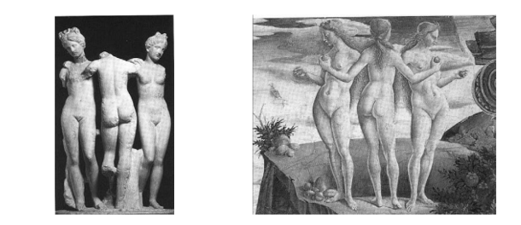
he three graces (Hellenistic period) Detail from Venus’s victory by F. del Cosa (1470)

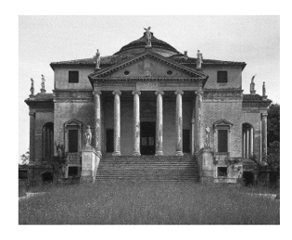
Villa Rotonda (1567) near Vicenta by palladio

’It is true for everything you have learnt so far. Judge all for yourself, and reject all for which you do not have reliable proof. Religion is founded upon faith, but sciences must continually seek certainty.’ (Renaissance author G. Agricola)

„Jó mindenre, amit eddig megtanultál. Ítélj meg mindent magad, s vesd el azt, amire nem találsz meggyőző bizonyítékot. A vallás hiten alapul, ám a tudományoknak folytonosan bizonyosságokat kell keresnie.” (G. Agricola, reneszánsz író)

’An as yet unseen accumulation of wealth started in the second half of the Middle Ages, and this prosperity concentrated in cities like Venice and Florence, which specialised in trade and the circulation of money [...]. Through this accumulation of wealth those who lived in affluence found pleasure in supporting the arts and literature. They had monarchs, popes and princes in their ranks.’ (The Renaissance by Paul Johnson)

„A középkor második felében tehát a történelemben addig nem tapasztalható vagyongyarapodás vette kezdetét, s ez a jólét főként az újdonságnak számító kiterjedt kereskedelemre és pénzforgalomra szakosodott városokra, mint például Velencére és Firenzére koncentrálódott [...]. A vagyon felhalmozása folytán azok, akik bőségben éltek, a művészetek és irodalom támogatásában lelték örömüket; soraikban uralkodók, pápák és fejedelmek voltak.” (Paul Johnson: A reneszánsz)

_____________________________________________________________________________________________________________________
_____________________________________________________________________________________________________________________
_____________________________________________________________________________________________________________________
_____________________________________________________________________________________________________________________
_____________________________________________________________________________________________________________________
_____________________________________________________________________________________________________________________
_____________________________________________________________________________________________________________________
_____________________________________________________________________________________________________________________
_____________________________________________________________________________________________________________________
_____________________________________________________________________________________________________________________
_____________________________________________________________________________________________________________________
_____________________________________________________________________________________________________________________
_____________________________________________________________________________________________________________________
_____________________________________________________________________________________________________________________
_____________________________________________________________________________________________________________________

12. This task is about the history of Islam and the Arab world. (short)
Describe the development and most important features of the Islamic religion, using the sources and your own knowledge. Use your secondary school historical atlas too.

’Allah – there is no other god beside him – is the living one who exists within himself. He is the sublime and the almighty. Mohammed is Allah’s delegate, the prophets’ seal. Allah is the knower of all things. Preach the glory of your Lord before sunrise and sunset. And praise him in certain hours of the night, and at the two ends of the day. Turn your face towards the Holy Mosque! Donate from those precious things that you have obtained, and from those which we have made to grow for you from the earth. Fasting has been prescribed for you. The time of fasting is the month of Ramadan. Fill then the number of prescribed days, and praise Allah! Do the pilgrimage. The pilgrimage takes place in the known months.’ (Koran)

„Allah – rajta kívül nincsen más isten – az élő, a magában létező. Ő a magasztos és hatalmas. Mohamed Allah küldötte és a próféták pecsétje. Allah minden dolgok tudója. Hirdesd Urad dicsőségét napkelte és napnyugta előtt! És magasztald őt az éjszaka bizonyos óráiban, és a nap két végén! Fordítsd orcád a Szent Mecset felé! Adakozzatok azokból a becses dolgokból, amelyeket szereztetek, és azokból, amelyeket kisarjasztottunk nektek a földből. Előíratott nektek a böjtölés. A böjt ideje a ramadan hónap. Töltsétek hát be az előírt napok számát, és magasztaljátok Allahot! Végezzétek el a zarándoklatot. A zarándoklat az ismert hónapokban történik.” (Korán)

’Isa [Jesus] is the Messiah, son of Marjam [Mary], Allah’s delegate, and do not say that there are three of them. It is better for you to refrain from this. Allah is only alone, all by himself.’ (Koran)

„Isza [Jézus] a messiás, Marjam [Mária] fia, Allahnak követe, és ne mondjátok, hogy hárman vannak. Rátok nézve jobb, ha ettől tartózkodtok. Allah csak egyedül, egymaga van.” (Korán)

_____________________________________________________________________________________________________________________
_____________________________________________________________________________________________________________________
_____________________________________________________________________________________________________________________
_____________________________________________________________________________________________________________________
_____________________________________________________________________________________________________________________
_____________________________________________________________________________________________________________________
_____________________________________________________________________________________________________________________
_____________________________________________________________________________________________________________________
_____________________________________________________________________________________________________________________
_____________________________________________________________________________________________________________________
_____________________________________________________________________________________________________________________
_____________________________________________________________________________________________________________________
_____________________________________________________________________________________________________________________
_____________________________________________________________________________________________________________________
_____________________________________________________________________________________________________________________

